Thesis proposal: SLAM robustness with object detection

# Motivation

Efficient understanding of both geometric and semantic characteristics of the environment are needed so that robots or XR devices can appropriately perform requested tasks and understand the local physical environment. Simultaneous localization and mapping (SLAM) algorithms allow the XR device to simultaneously geometrically map the environment and localize itself within the environment. However, SLAM has stability issues in dynamic environments where the features of the environment and the XR device both move. Visual SLAM systems suffer from accumulated errors leading to erroneous pose estimates of a robot, inconsistent maps, ultimately leading to failure when performing in dynamic environments.

In the other hand, object detection (OD) models can be used to semantically understand what those “features” in the environment represent or mean. But object detection has performance issues in complex environments due to lighting conditions, occlusion, motion blur, etc. Joint SLAM and OD can help each-other to improve the robustness of SLAM algorithms and performance of object detection models.

At Ericsson we are investigating how to perform joint detection and SLAM in a way that such processes benefit from each other. Specially in dynamic environments, where moving objects interfere with the SLAM algorithm relying on static features for localization and visual odometry. In such environments, moving elements need to be considered to reduce false matches and unpredictable system errors.

The SLAM framework being used is Maplab (Figure 1), a visual-inertial mapping framework for processing and manipulating multi-session maps (e.g., from multiple devices) within the Robot Operating System (ROS).

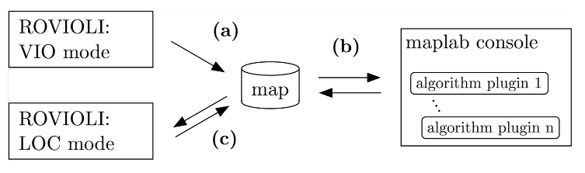

Figure 1 Maplab framework workflow. Running Rovioli (front-end) in Visual-inertial Odometry mode and Localization mode.

# Master thesis proposal

We are looking for a master thesis student who can help us carrying out research on how to improve visual/visual-inertial SLAM robustness in dynamic environments by using object detection, for example, by understanding the impact or localization error through identifying moving object features and filtering them from the localization process. Also, to implement a ROS wrapper and/or ROS library that allows to study and evaluate this impact.

The scope of the thesis includes but not limited to:

1. Develop a thesis plan and identify research questions related to improving SLAM robustness using object detection
2. Become acquainted to ROS and maplab
3. Become acquainted to object detection or segmentation frameworks using RGB and/or pointclouds.
4. Carry out a literature survey on prior works related to joint SLAM and object detection
5. Develop a study and experimental setup
6. Develop a ROS wrapper/libraries for a proof of concept.

# Supervisor(s):

Master thesis supervisors at Ericsson are Héctor Caltenco and Saeed Bastani, who will be able to help with administrative matters, purchase of material and general Ericsson related issues, as well as take care of project matters and research related questions.

|  |  |  |
| --- | --- | --- |
| Héctor Caltenco | [hector.caltenco@ericsson.com](mailto:hector.caltenco@ericsson.com) | +46 72 507 8918 |
| Saeed Bastani | [Saeed.bastani@ericsson.com](mailto:Saeed.bastani@ericsson.com) | +46 72 468 6297 |

An academic supervisor at KTH is also needed.